| **Test Name** | | Successful login | | | |
| --- | --- | --- | --- | --- | --- |
| **Use Case Tested:** | | Use Case 13 – Log in | | | |
| **Test Description:** | | User wishes to enter an error.  User enters a valid username.  User enters a valid password that relates to the username.  User selects Submit button.  User is presented with the Enter an Error page. | | | |
| **Pre-conditions** | | A valid user name and password exists for user with administrator authority level | | | |
| **Post-conditions** | | Enter an Error page is presented to user for completion  User will have other selection options available in the menu bar. | | | |
| **Notes:** | | *However, as the other options are outside the scope of LCAM, no testing of the options will be completed and selecting the options other than Logout may result in an error occurring.*  *Unsuccessful Administrator Login not tested as this will be a repeat of Unsuccessful User Login*  *Screenshots relating to test can be found after the Test Data Table* | | | |
| **Result (Pass/Fail/Warning/Incomplete)** | |  | | | |
|  | **TEST STEP** | | **EXPECTED TEST RESULTS** | P | F |
|  | User enters valid username | | No error appears | P |  |
|  | User enters valid password that relates to username | | No error appears | P |  |
|  | User selects Submit button | | Enter an Error page appears | P |  |
|  |  | | Menu bar shows extra options being available to the User – *see note above* | P |  |

|  |  |  |  |  |  |
| --- | --- | --- | --- | --- | --- |
| **Test Data Table** | | | | | |
|  | **1** | **2** | **3** | **4** | **5** |
| Valid Username: | admin@test.com |  |  |  |  |
| Valid Password: | super123 |  |  |  |  |
|  |  |  |  |  |  |

SCREENSHOTS RELATING TO TEST

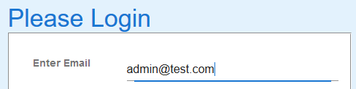

Valid administrator password entered

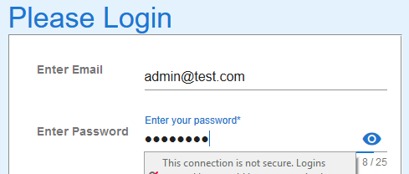

Valid password entered and submit button clicked

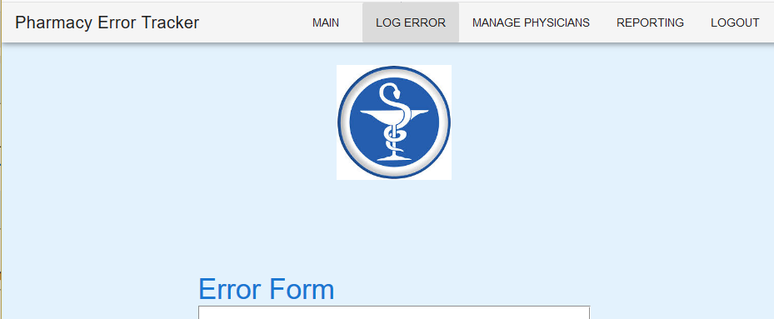

Error form presented with various other buttons available to administrator.

Clicking LOGOUT returns administrator to Login Page

